Copyright and Fair Use

Overview
Adhering to copyright guidelines is crucial when using third-party materials in your course. Using others’ writing, artwork, ideas, videos, pictures, and other content without understanding the terms of use may result in legal or ethical issues. Instructors are responsible for complying with all copyright laws throughout the course design and development process. Review the TAMU Library Research Guide on Copyright online for more information.
This guide provides information on using content for instructional purposes that aligns with copyright and fair use guidelines. It includes the following sections:
- What is Copyright?
- What is Fair Use?
- Determining Fair Use
- Case Studies of Assessing Fair Use
- Citation of Works
- Citations for AI Generated Content
- Image Attributions

What is Copyright?
All content found online or in print is protected by copyright. The U.S. Copyright Office states that copyright is held by the creator from the moment a work is generated. This means the absence of a copyright notice on a material does not mean that the work in question can be used or copied freely, or that it does not have copyright protection. Copyright extends beyond copying and includes reproducing, distributing, and modifying third-party materials. Any use of or reference to third-party materials falls under copyright. Ideally, copyrighted materials should not be copied, altered, or distributed without express permission from the owner or author. Any materials used for instructional purposes must be cited.
According to the U.S. Copyright Office, any instance where AI is used as a tool, and where a human has been able to determine the expressive elements they contain, AI outputs are copyrightable (2025). For example, if one uses AI to brainstorm ideas for an assignment, then creates the assignment themselves, the final product is copyrightable by the individual. However, if one directly copy/pastes the output from AI to use as a source of information, then a citation of the AI is required. This is described more in Citations for AI-Generated Content.

What is Fair Use?
Fair use guidelines are legal allowances for the use of copyrighted material in specific settings without a license or any permission from the creator.
Before using third-party materials, identify the copyright holder, evaluate fair use eligibility, provide proper attribution, and obtain necessary permissions when required.
Understanding fair use is essential when selecting course materials. Fair use is a legal doctrine that allows limited use of copyrighted material without permission for purposes such as teaching, research, criticism, and news reporting. However, determining whether a specific use qualifies as fair use requires careful evaluation.
Before using third-party materials, consider the following:
- Identify the copyright holder
- Assess whether the material qualifies under fair use
- Provide proper attribution
- Obtain necessary permissions when required
The Copyright Clearance Center has various resources available about copyright and fair use, including the following:
- Video: Copyright on Campus
- Video: Copyright Basics

Determining Fair Use
When evaluating if your use of a copyrighted work qualifies as fair use, consider these four factors:
- Purpose and Character of Use
  - Nonprofit educational purposes favor fair use.
  - Transformative use (adding new meaning, context, or value) strengthens a fair use claim.
  - Commercial or purely duplicative use is less likely to qualify.
- Nature of the Copyrighted Work
  - Factual and published works are more likely to fall under fair use than creative, unpublished works.
  - Using informational content (e.g., research articles) is more permissible than fictional or artistic works.
- Effect on the Market or Value
  - If the use negatively impacts sales or licensing opportunities, it is less likely to be considered fair use.
  - If the material is readily available for purchase or licensing, fair use is harder to justify.
These categories are intentionally broad. By answering the questions above and weighing how many factors are for or against fair use, you can determine if your use of a work would qualify as fair use. The University of California (2021) boils this down into two questions to ask when considering a work for fair use:
- Are you planning to use the work in a separate way, or for a different purpose, than the original creator? In copyright terms, is your use “transformative”?
- Are you using that work that is narrowly tailored to your new purpose? (University of California, 2021, Fair Use for Teaching and Research)
If the answer to both questions is “Yes,” then the usage qualifies as fair use. The Copyright Clearance Center has a quick guide that discusses fair use as it relates to learning management systems, such as Canvas.
The following tables provide more specifics for determining fair use of content in different formats.

Determining Fair Use of Print Materials
Type of Material | Fair Use Examples | Fair Use Non-Examples | Things to Consider
Journal Articles  Distributing or assigning articles for learners to read. | - Using one or two articles from a periodical  - Using only a short excerpt  - Using <10% of original text | - Repeated use, from term-to-term, requires scrutiny  - Charging learners for access | - Provide a citation for the journal. It is best not to combine different articles together as a single packet for learners as this can be considered an anthology.
Online Publication of Lecture Notes  Using a web page to share course content with learners. Course content may include third-party materials for learners to access. | - Using a web page that has restricted access allowing only current learners to view the content and following the copyright for any content included in the lecture. | - Using public web pages to share course content | - Sharing copyrighted material on web pages with public access is likely to violate the copyright agreement because it is being distributed to the public, not just to learners enrolled in the course.
Textbooks  Using a textbook as reference material for the course. | - Placing a copy of the textbook on reserve  - Requiring learners to purchase the book | - Making copies of the textbook or sections of the textbook and distributing it to learners. | - Authors usually hold a monopoly on the marketing and production of materials.
Public Domain  Using public domain material in your course. For example, works produced more than 96 years ago (In 2023, that year would be 1927), works dedicated to the public, and works not protected by copyright laws | - Any works in the public domain can be altered, reproduced, and distributed. | - Due to the nature of public domain, resources found in the public domain can be used in any manner and are therefore considered fair use. | - Stanford shares a helpful resource about public domain.
Unpublished Work  Using unpublished letters, manuscripts, journal entries, or other written work not intended for publication or not yet published. | - You can edit and publish unpublished works if the copyright protection has expired and/or if the owner or living author grants permission. | - Using any unpublished work which has active copyright protection without permission. | - The Copyright Alliance FAQ is a good reference for definitions of unpublished work.
Out-of-Print Books  Using books or textbooks that are no longer in print or circulation. | - Making copies for personal files or for strictly educational purposes  - Placing a copy on reserve in the library for learner access | - Placing the text of the book on a web page.  - Reproducing the book for distribution among learners | - For information about republishing a book that is out of print, check out this article in Legal Beagle.

Determining Fair Use of Visual Materials
Type of Material | Fair Use Examples | Fair Use Non-Examples | Things to Consider
Photographs or Visual Images  Using photographs, images, graphics, charts, tables, graphs, etc., whether in physical or digital formats. | - Including thumbnails in electronic presentations  - Using photos without changing any attributes  - Discussing the image in a class or learning environment | - Publishing presentations on the internet with public access and including the images  - Charging access fees for distributing and copying | - Check permission of the media item and adhere accordingly. Photographs used for instructional purposes are allowed. Cite original content appropriately. Tables and graphs are treated as images when it comes to copyright.
Book Covers  Using images of book covers. | - Using thumbnails or low-resolution images. | - Using high resolution/ full content without permission. | - In many instances, book cover art is not created by the author and/or copyright is not held by the publisher. Obtaining permission is usually the best way forward.
Video Tape with Unexpired Copyright  Showing video content that has an active copyright and is not in the public domain. This can be a physical or digital copy. | - Showing a video tape in the classroom for instructional purposes | - Charging admission fees  - Copying and distributing content among learners | - For more information, review the University of Illinois Chicago’s Copyright and Fair Use: Examples: Video
Video Tape with Expired Copyright  Showing video content that has an expired copyright and/or is in the public domain. This can be a physical or digital copy. | - Making copies of the work  - Charging admission fees (approved by appropriate authorities) | - There are no non-examples. Video tapes with expired copyright can be altered, copied, and distributed without prior approval from anyone. | - Verify that the video tape has no active copyright. It is important to crosscheck the copyright information on the film with the copyright holding party.
Online Videos  Using videos from YouTube, Vevo, Vimeo, or other online platforms. | - Showing the video in class  - Sharing a link and/or directing learners to view the video online  - Embedding the video content in Canvas | - Charging admission fees  - Copying and/or altering content for other purposes | - Online videos have strict copyright policies that prevent users from altering, distributing, and copying without approval. Cite online videos including those marked “Creative Commons.”
Commercial Videos  Showing movies, films, or other commercial videos. | - Showing 5-to-10-minute excerpts in class for instructional purposes (a citation is needed for the movie) | - Charging admission fees  - Copying and/or altering content  - Showing the entire movie in class | - Commercial films have strict marketing, editing, sale and distribution copyrights. Simply citing is not enough.
Video from Streaming Services  Showing video content from on-demand subscriptions from streaming services such as Apple TV, Hulu, Netflix, etc. | - Videos from streaming services have special copyright status that prevents the showing of content in public spaces including educational environments. Refer learners to watch the video content using their account and subscriptions. | - No use of this content is considered fair use | - The terms of the agreement between the subscriber and the subscription service govern whether movies from subscription services can be shown in the classroom. If the agreement states use is limited to 'personal' or 'household' use, classroom use is not allowed.

Determining Fair Use of Audio Materials
Type of Material | Fair Use Examples | Fair Use Non-Examples | Things to Consider
Music  Sharing music, songs, or tracks that are under active copyright and/or are not considered in the public domain. | - Using commercial music in face-to-face or synchronous presentations for classroom instruction | - Copying, altering, and/or selling to learners  - Publishing or uploading music or presentations containing music to webpages with public access  - Uploading music to Canvas | - Many believe that using up to 30 seconds of a song guarantees fair use, but there is no specific duration that has been universally accepted as fair use for music.  Commercial use of a 10-second clip might infringe on copyright, whereas educational use of the same clip could qualify as fair use. For more information, visit Softhand Tech website.
Podcasts  Sharing podcast episodes accessed from any platform. | - Playing a portion of an episode as part of class instruction  - Sharing a link to a podcast episode | - Uploading podcast episodes to Canvas  - Copying, altering, and/or selling podcast content with learners | - See considerations from the previous section about music.
Interviews or Other Audio Recordings  Using audio recordings such as interviews, news reports, speeches, etc. | - Sharing short excerpts from the audio recording and citing it appropriately  - Sharing a link or directing learners to access the audio recording  - Playing clips of audio that is considered public domain | - Uploading recording files to Canvas  - Copying, altering, and/or selling content with learners | - Interviews and audio recordings are treated as commercial music and must be treated as such.

Case Studies of Assessing Fair Use
The following sample scenarios model the process of evaluating whether the use of copyrighted work would be considered fair use. For more examples, review Stanford University Library’s summary of fair use cases or Richard Stim’s list of Supreme Court fair use cases.

Example 1: Assessing Fair Use of a Textbook
The instructor of a human anatomy course would like to use an old edition of a popular anatomy textbook. Though the new edition is available, the old one is out of print. The course instructor would like to upload a scanned copy of the old edition into the course for learners to use. Is this fair use?
- Are you planning to use the work in a separate way, or for a different purpose, than the original creator? In copyright terms, is your use “transformative”?
  - No. While it will be used for educational purposes, this use is not transformative. The textbook will be used in the same way it was created to be used.
- Are you using that work that is narrowly tailored to your new purpose?
  - No. The instructor plans to use the entire textbook.
After answering the two questions above, we can determine this is not fair use. Instead, the instructor should require learners to purchase the new edition or select a small portion of the original edition to be used in class.

Example 2: Assessing Fair Use of an Art Piece
The instructor of an art course would like to use Banksy’s Girl with Balloon to discuss and critique graffiti art. The instructor would like to add the image to a PowerPoint slide to share in class and upload it to the online course. Is this fair use?
- Are you planning to use the work in a separate way, or for a different purpose, than the original creator? In copyright terms, is your use “transformative”?
  - Yes. Not only will it be used for educational purposes, but it will also be used for discussion and critique. This is different from its original purpose.
- Are you using that work that is narrowly tailored to your new purpose?
  - Yes and no. The amount used is the entire work, but since it is an art piece, its use is specific to its new purpose of discussion and critique.
After answering the two questions above, we can determine that this usage would be fair use. The instructor can add this image into the course. However, the instructor still needs to give proper attribution to the owner. Read the Citation of Works section below to learn about how to cite a resource under fair use.

Example 3: Assessing Fair Use of a Video
The instructor for a data science course would like to upload a video on the Hadoop Ecosystem into the course. The video is on YouTube and is owned by an educational data science channel. Is this fair use?
- Are you planning to use the work in a separate way, or for a different purpose, than the original creator? In copyright terms, is your use “transformative”?
  - No, the use will not be transformative. The video would be shown solely to explain the Hadoop Ecosystem, which is no different from the original intention of the video.
- Are you using that work that is narrowly tailored to your new purpose?
  - No. The instructor would like to use the entire video.
After answering the two questions above, we can determine that this would not be fair use unless the video is marked as Creative Commons. If it is not, the instructor could still link out to the video as a supplemental resource but could not directly copy the video into the course.

Citation of Works
Once you have determined that a work can be used under fair use, it needs to be properly cited. Whether it is embedded into a PowerPoint presentation, uploaded as a file into a course, or shared in a virtual classroom session, credit should be given to the copyright holder wherever the material is used.
With the exception of referencing the textbook in the syllabus, you may wish to use an abbreviated APA citation style throughout the course (seen below). You can learn more about online citations from Purdue University’s Online Writing Lab.

Entire Works
Format: Last Name, First Initial. (Year). Title (hyperlinked if the source is available online).
Examples:
- Smith, B. (2019). Introduction to guide usage.
- Banksy. (2002). Girl with balloon.

Chapters of a Work
Format: Chapter # (if relevant): Last Name, F. (Year). Title of work.
Examples:
- Chapter 8: Sam, J. (1809). Birds of many kinds.
- Chapter 12: Pugh, F., Kim, P., & Straten, J. (1996). The life of a bear.

Citations for AI-Generated Content
When citing AI-generated content in APA format, it's important to provide clear attribution and documentation of the AI tool used. The basic format follows the standard APA structure but includes specific elements for AI sources.
The citation should include the author (company/organization that created the AI model), the year of the version being used, the model's name and version, and a description of the technology in brackets, followed by the source URL.
For example, a citation for ChatGPT would be structured as:
OpenAI. (2025). ChatGPT (Feb 14 version) [Large language model]. https://chat.openai.com.
In text, this would be referenced as (OpenAI, 2025).
The URL should be specific to the chat where the cited content originated, as many AI platforms now provide sharing capabilities for specific conversations.
Key elements to include in AI citations are:
- The author (the company/organization that created the model)
- The date (year of the version used)
- The title (model name and version number in parentheses)
- Additional descriptions in brackets
- The source URL (when the publisher and author are the same, omit the publisher’s name)
For more on AI citation, go to How to Cite AI-Generated Content.

Image Attributions
Properly attributing images and other intellectual property is a legal necessity and a responsibility to best practices in digital standards of academic integrity. Clear and accurate attributions pay respect to creators of original works and reinforce transparency in the learning environment. The purpose of attribution is to acknowledge the original creators of materials such as photographs, illustrations, charts, and multimedia. Failure to correctly attribute, secure rights and follow licensing terms can result in copyright infringement and legal ramifications.

Crafting Attribution Statements
In courses and materials, attributions should give learners enough information to identify the source and verify the legal usage of every image and media element. A complete attribution typically includes four elements: Title, Author, Source, and License the T.A.S.L. framework.
Title – Provide the name of the work if one is available. Alternatively, you can provide a short description.
Author – Name the creator or owner of the work. Use the name as it appears in the source.
Source – Include a clear reference and a direct link to where the source was found. If this is a licensed database or collection, the image will be linked via the database source rather than the individual image.
License – Make note of the license type or usage permission. For Creative Commons-licensed materials, list the full license name and link to the license details.

Some Additional Notes
- Consistent formatting of attributions is important so that the learner always knows how to find a source.
- Best practice is to place attributions directly below the image and remain consistent in structure and size.
- If an image has been altered (cropped, filtered, etc.) or is a derivative of a work, this should also be mentioned in the attribution.
- There are online attribution builders such as Creative Commons Attribution Builder or Attribution Builder at RMIT.

Missing Components in Attributions

There will be times in which you encounter incomplete attribution information such as missing titles, creators or licenses details. To ensure academic integrity, try to locate the information.
- Attempt to locate the missing information by finding the source of the image or material.
  - Do a reverse image search with Google Images by copying the image and pasting it into the search field. You can then narrow your search by adding search criteria.
  - Search image data bases using keywords
- Address the missing information with transparency and caution. All creative works are automatically protected by copyright unless explicitly released under public or open licenses. When licensing information can’t be confirmed, if possible, replace the material with material from a known source.
- As a last resort option, clarify the purpose of the use of the material. Statements such as “for illustrative purposes only” or “has no known copyright restrictions” or “used under fair use provisions for educational use” don’t completely alleviate the burden of responsible use, but they provide transparency and an acknowledgment of due diligence.

Special Images

Screenshots
Screenshots used for demonstrative and educational purposes are legal to use but do require attributions. Some companies such as Microsoft have specific terms of use for screenshots of their platforms, so check licensing agreements. A standard attribution for a screenshot that you personally captured would include a brief description of the shot, screenshot by author, and the date of capture.

AI Generated Images
In part, the ethical motivation for citing AI generated images is the technology and its developers who make the images possible. Although there is an individual who generates the prompt, the attribution’s purpose is to provide clarity about the origin of the content. When formatting these attributions, you will include information about the AI tool or platform used, the AI developer, details about the prompter, and any applicable licenses.

Clarifying Common Misconceptions
- Public domain and free to use are not the same. Images in the public domain are free for anyone to use without permission. Copyright on these images is either expired or waived by the owner. Free to use images don’t carry a financial cost, but they can still carry legal obligations to credit the creator under the licensing agreement.
- Images on social media are not free to use just because they’re already in public view. The creator of the image still holds copyright ownership, and most social media platforms prohibit the use of someone’s image without permission.
- Images found on Google are not free to use. Google and Google Images are simply search tools. These tools locate images, but just because an image was found doesn’t mean it can legally be used.

Examples
Image | Attribution Statement | Note
 | Sunrise in Tomball by David Banning on Unsplash, used under Unsplash License. | This attribution has all the necessary components. Additionally, the Source (Unsplash) and the license for use (Unsplash License) are both linked for easy reference.
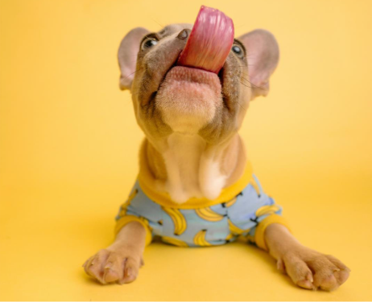 | Bananas! by Karsten Winegeart on Unsplash has been modified (cropped) and is used under Unsplash License. | This image was altered from its original state by cropping empty space for a tighter focus. This is noted after the mention of the database where the image was found.
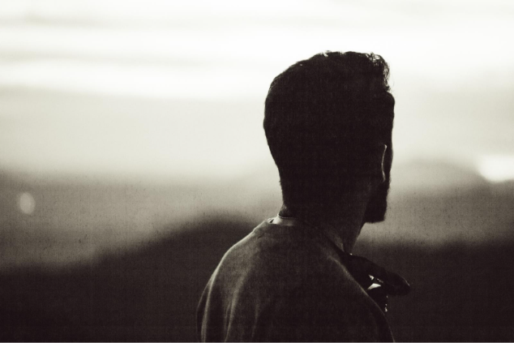 | Man looking at horizon by unknown creator designed by Freepix used under the Free Licenses. | This attribution, which uses a description in place of a missing title, is also missing the creator of the image.
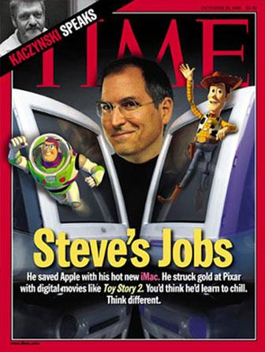 | TIME Magazine, October 18, 1999. Cover illustration featuring Steve Jobs, Pixar's Buzz Lightyear and Woody, used under fair use provisions for educational use. | This attribution is used to show the original source of the image; however, it emphasizes with the final component that it’s being used for an educational purpose separate from its original intent.
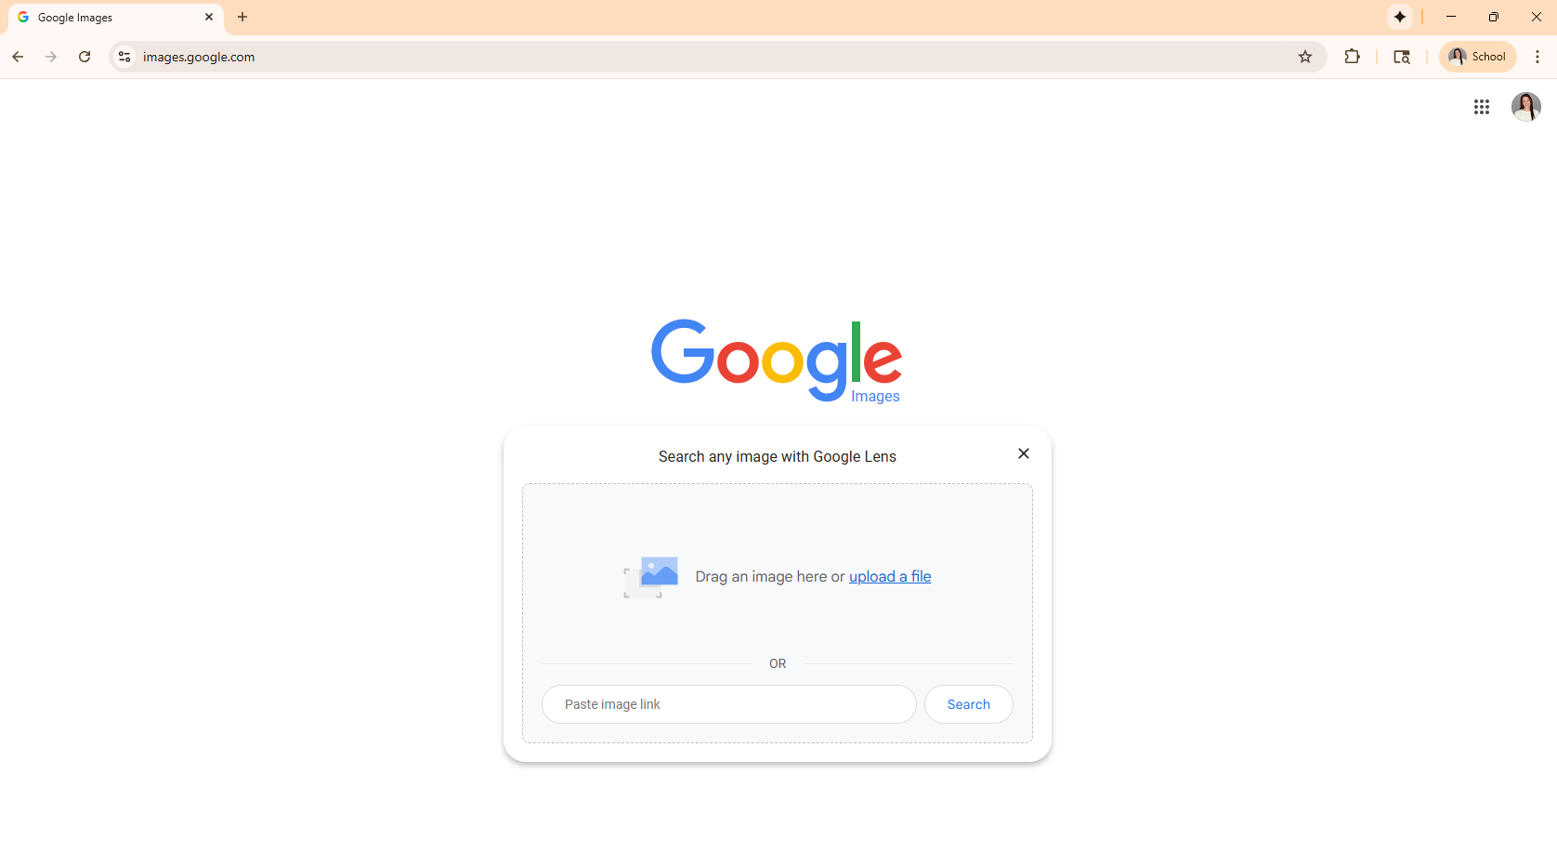 | Screenshot of Google Images search page, screenshot by Jane Doe, October 16, 2025. | The platform in the screenshot has creators. This attribution is meant to give credit to those who created the platform/software in the image.
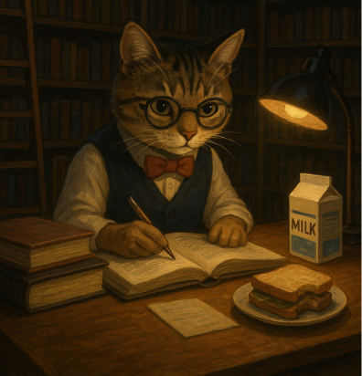 | Studious Cat in a Library generated by ChatGPT (DALL·E) prompted by Jane Doe. | The creator of prompt, if it was not you, as a best practice, is mentioned in the attribution.
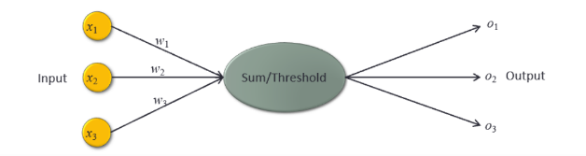 | Detailed neuron structure and connection weights by Bin Zhang for use in ISTM 650 at Texas A&M University. | Faculty created images that haven’t been copyrighted should get an attribution crediting him/her for its creation for the course.

Resources
- Barker, L. (n.d.). How to republish a book that is out of print.
- BCampus. (2018). Resources: Captions and attributions.
- Copyright Alliance. (2025). Publish vs. unpublished works.
- Copyright Clearance Center. (n.d.). Copyright on campus..
- Copyright Clearance Center. (n.d.). Copyright basics.
- Creative Commons. (2024, September 30). Recommended practices for attribution.
- Lynch, J. & Hooper, A. (2019). Can I use that video on my website?
- Oregon State University Ecampus. (2018). Attribution of images and other openly-licensed content.
- PicDefense. (2024, November 5). 5 common misconceptions about image copyright you need to know.
- Purdue University Library and School of Information Studies. (n.d.) How to cite AI-generated content.
- Sharrow, T. (2025). How Many Seconds of a Song is Fair Use?: Understanding Copyright in Music.
- Stanford Libraries. (2025). Copyright & fair use: Charts and tools.
- Stanford Libraries. (2025). Welcome to the public domain.
- Stim, R. (n.d.). Fair use: The four factors courts consider in a copyright infringement case.
- Stim, R. (2019). Welcome to the Public Domain.
- University of California. (2021). Fair use for teaching and research.
- U.S. Copyright Office. (n.d.). Limitations on exclusive rights: Fair use.
- U.S. Copyright Office. (2021). What is copyright?
- U.S. Copyright Office. (2025). Copyright and artificial intelligence.
- University of Illinois Chicago. (2023). Copyright and fair use: Examples: Video.

